Moldova: Civil Society Driving Transparency in Procurement
Results & Opportunities to build on the progress made
(June 2024)
Overview
Duration: September 2020 – June 2025
Partners: Partnership for Transparency (PTF), Washington DC, USA; Institute for Development and Social Initiatives “Viitorul” (IDIS), Chisinau, Moldova
Funding: USD1,727,357 by the United States Government
Abstract: In 2020, the project partners embarked on a program to enhance the capacity of civil society organizations (CSOs) and investigative journalists in Moldova to engage in informed and responsible monitoring of public procurement processes. The project aims to support procurement reforms that increase the transparency and fairness of public procurement by empowering citizens to hold relevant institutions accountable and catalyze integrity across the procurement ecosystem.
Details: Project Website
Theory of Change
If civil society and investigative journalists
- are trained and supported to meaningfully monitor procurement processes (training), and
- they succeed in monitoring procurement procedures and documenting irregularities (monitoring), and
- they extract lessons and share recommendations in a cooperative and institutionalized way with stakeholders to improve norms and practices (policy dialogue),
then they hold stakeholders involved in public procurement accountable, inducing them to operate with greater integrity to perform their duties more effectively, while also contributing to improve relevant laws, regulations, processes, thereby enhancing country’s procurement system (increased integrity in public procurement)
Logic Framework and Implementation Approach
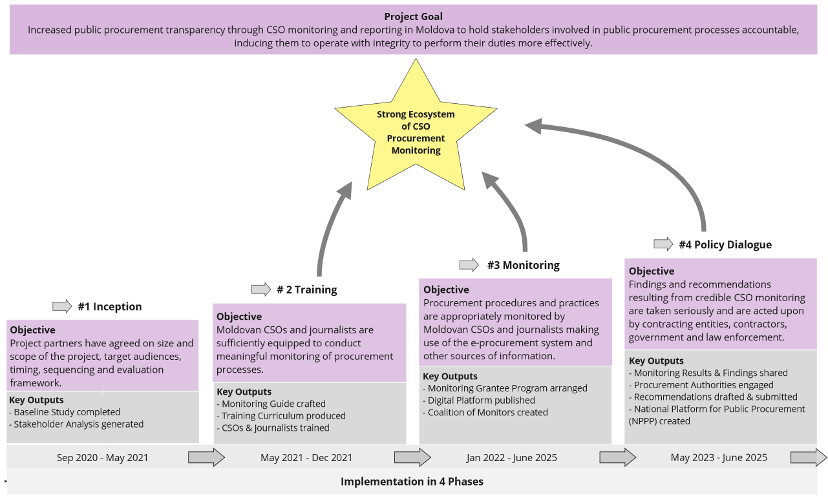

Implementation Phases and Key Outputs
#1 Inception
To understand the situation of public procurement in Moldova including opportunities for, and the capacity and willingness of civil society to conduct meaningful monitoring, the team consulted stakeholders in person and through an online survey. The results formed the basis for the theory of change and the project plan.
- Baseline Study of the legal and regulatory environment in Moldova completed.
- Stakeholder Analysis conducted, based on consultations and interviews with key entities and agencies involved in public procurement in Moldova, international donors, CSOs, investigative journalists, and associations of economic operators.
#2 Training
To strengthen the capacity of CSOs and to support their procurement monitoring activities, guiding material was developed and delivered to capable and willing candidates selected through a competitive application process.
- Monitoring Guide crafted, providing guidance for CSOs to monitor procurement processes at different levels of government.
- Training Curriculum designed and delivered to 34 CSO and investigative journalist organizations.
#3 Monitoring
To foster active monitoring of public procurement processes, civil society and investigative journalists are supported. A three-pronged approach aims at contributing to the project objectives on two levels: case related issues (findings discovered in monitored procedures) and systemic issues (common themes and lessons learned across monitoring projects). The former are rectified where feasible, the latter serve as basis for recommendations to improve the national procurement system in the Policy Dialogue.
- Digital Platform: a one-stop-shop website providing resources for anyone interested in monitoring public procurement in Moldova is developed, launched (June 2024), and maintained until at least the end of the project.
- Subgrants Program: CSOs and investigative journalists received funding and mentoring in two cohorts to monitor procurement processes. A total of USD300,000 was disbursed on a competitive basis in 13 grants of up to USD25,000 each. The grantees receive mentoring and technical support including peer-learning exchanges between April 2022 and September 2024. Findings of their monitoring activities are brought to the attention of authorities and form the basis for recommendations to improve the national system of public procurement.
- Coalition of Monitors: based on the concept that “strength is in numbers”, a Coalition of Monitors was formed. IDIS is functioning as the secretariat, convening it on a quarterly basis to share experiences and extract lessons learned to develop policy recommendations that will improve the national procurement system.
#4 Policy Dialogue
To ensure the case-related findings lead to systemic improvements at the level of laws, regulations, policies, processes and practices, the project set up and supports a National Platform on Public Procurement (NPPP). The team is also conducting outreach to share the lessons learned in Moldova and beyond.
- National Platform on Public Procurement: a multistakeholder forum was set up to engage relevant and influential actors in regular conversations on core issues pertaining to public procurement in Moldova, including the Ministry of Finance (MoF), other government entities, CSOs, and private sector representatives. The NPPP formulates recommendations, in many cases based on findings from monitoring, and shares them with MoF and other entities to improve public procurement in Moldova.
- Publicity & Reporting: the team is reaching out to partners and funders to identify support for continued efforts in Moldova around the availability of technical tools or sector-based approaches, but also to identify opportunities to bolster progress through similar projects in other countries.
Results in Numbers (as of June 2024)
 | #1 Inception | #2 Training | #3 Monitoring | #4 Policy Dialogue
Outputs | - 1 Baseline Study published  - 1 Stakeholder Analysis with insights from 27 partners  - 1 online project launch conference with 150 participants across sectors (Sep 2021) | - 1 Monitoring Guide published  - 71 training materials developed, ready to be adapted elsewhere  - 34 CSOs & Journalists trained in person during 24 sessions in 12 modules (Oct-Dec 2021) | - 186 procurement procedures of 71 contracting authorities monitored by 10 organizations in 13 projects, with an estimated total value of USD93.3 (first round)  - 69 mentoring sessions provided to 10 CSOs  - 1 Coalition of Monitors with 31 members established, 4 quarterly meetings held  - 1 Digital Platform developed and launched (June 2024) | - 1 National Public Procurement Platform with 19 key stakeholders from all sectors created and operated by IDIS as the secretariat  - 3 memoranda of cooperation signed with key public sector stakeholders  - 206 publications produced including articles, newsletters, reports, social media posts, TV and talk shows
Outcomes |  | - Enhanced capacity of training participants: participants’ self-assessment of their knowledge of Public Procurement monitoring as (very) good increased from 20% pre-training to 86% post-training | - 86 recommendations shared with public authorities in 19 districts across 3 levels of government (first round of grants)  - Enhanced capacity of CSO monitors: 100% of subgrantees reported an improvement in their monitoring skills after implementation of their projects (first round) | - 2 quarterly meetings held including preparation of topics, discussions, resulting in recommendations  - 5 recommendations agreed (first NPPP meeting), submitted to MoF and the Ministry of Infrastructure, currently under review by the Ministries
Impact |  |  |  | - 1 MoF endorsement of and participation in the NPPP, incl. consideration of recommendations formulated by the Platform  - First systemic improvements emerge: 4 monitored authorities partially changed their behavior (first round); 2 monitored authorities corrected their behavior following recommendations (second round)

Most Significant Achievements (as of June 2024)
#2 Training: Building Capacity
In 2021, 34 participants completed the 12 day in-person training delivered over a period of 3 months. Most significant achievements include:
- Increased capacity: participants self-assessed an overwhelming increase in their knowledge of public procurement across modules and topics.
- Increased motivation: while 60% of the training participants had previously engaged in monitoring Public Procurement, 93% of them intended on doing so afterwards.
- Continued engagement: 7 participants subsequently applied for the grants program, and 15 became members of the Coalition of Monitors.
- Encouraging first results: case studies developed during the training show very promising application of the knowledge provided – including on the health sector or the procurement around construction works of a sports stadium in the Cahul district.
#3 Monitoring: Ensuring active monitoring of Public Procurement
Between 2022 and 2024, 13 CSO monitoring projects of 9-12 months duration were supported by grants of up to USD25,000 each and mentored on a continuous basis. Most significant achievements include:
- Increased oversight: 71 contracting authorities’ (CAs) procurement procedures with a total estimated value of USD93.3m were subject to CSO monitoring.
- Increased participation: 6 grantees successfully requested by CAs to become non-voting members of the working group of the tender they were monitoring. This greatly enhanced transparency and accountability of these procedures and promoted with CAs the concept that CSOs are interested and capable of an oversight role.
- Increased transparency: 5 interventions by 2 grantees led to (1) the publication of previously undisclosed documents of procedures they were monitoring; (2) 2 CAs providing additional information: Ministry of Education added obligatory information on its website, Cahul Municipality provided information on publication of award notices.
- Increased awareness: 206 publications in a variety of formats and channels reached an audience of thousands of Moldovan and international individuals over four years.
- Improved procurement – case level:
  - 4 revisions of tender documentation, incl. 1 cancelation and retendering by Ministry of Labor and Social Protection.
  - 1 successful challenge by a grantee regarding information not provided by the CA (City Hall of Chișinău) resulted in a police-issued fine for the employee tasked with answering the request for public information.
- Improved procurement – system level: 86 recommendations were submitted by grantees to CAs and other authorities (MoF, National Anticorruption Center (NACS), National Integrity Authority). Follow up is ongoing. So far, 63 have been rejected or ignored and 1 grantee is pursuing a case in court. Positive changes of behavior attributed to the work of grantees have been observed:
  - MoF accepted a grantee’s recommendation that MoF and the Public Procurement Agency (PPA) should provide training for CAs on the application of Law 74/2020 (Procurement of Utilities) – implementation of the training is outstanding so far.
  - Ministry of Education improved its transparency in several areas (publication of information, decision processes, list and references to the legal framework, compliance with regulations, publicly available information of small value procurements) – corresponding to several recommendations submitted by a grantee.
  - Cahul Municipality started publishing previously undisclosed procurement documents including award letters, following the recommendation by a grantee.

#4 Policy Dialogue: Improving the System of Public Procurement
Project activities collectively contribute to a strong ecosystem of CSO monitoring. The ToC (p.2) and the Results (p.3) show that along the project logic, activities produce increasingly meaningful achievements supporting this overall purpose: (1) Monitoring activities produce case-based experience (findings and challenges); (2) the Coalition of Monitors digests these individual lessons and identifies overarching problems through peer discussions, supported by research, resulting in suggestions for improving the system from the CSO perspective; (3) the NPPP is the vehicle for producing recommendations that are considered by authorities – including the voice of Civil Society as expressed by the input through the delegates from the Coalition of Monitors. The NPPP is therefore the centerpiece of the Policy Dialogue to accomplish (a contribution to) systemic improvements, and in the long term, increased transparency, integrity, and accountability of public procurement in Moldova. Most significant achievements include:
- Consolidation of the voice of Civil Society: 28 CSOs and investigative journalists from the three regions of the country have joined forces by forming the Coalition of Monitors. Since June 2023, IDIS in its function as the secretariat has hosted 5 quarterly meetings to exchange experiences and to define proposed solutions to the common challenges experienced. In addition to peer exchange, meetings are dedicated to the topic of the next NPPP meeting – to allow the delegates representing the Coalition in the NPPP to express the view and recommendations of Civil Society in an agreed and consolidated form.
- Creation of an inclusive and committed multi-stakeholder dialogue: 18 institutions and organizations from all sectors joined the NPPP. Endorsed by the MoF as main player, these members include all major stakeholders in Public Procurement, e.g., Public Procurement Agency (PPA), Court of Accounts, National Anticorruption Center, NACS, Center for Centralized Public Procurement in Healthcare, Chamber of Commerce & Industry. Following extensive bilateral consultations over 8 months, the platform was launched in December 2023 and has so far met twice (on a quarterly basis). Each meeting is dedicated to a topic jointly identified by members as priority. Strong participation, productive discussions, and adoption of reports containing agreed recommendations for submission to and consideration by relevant authorities are convincing signs of the caliber of this achievement – taking the quality of inter-institutional dialogue in matters pertaining to public procurement to an unprecedented level.
- Formation of Partnerships: 3 memoranda of cooperation were signed between IDIS and MoF (September 2023), the NACS (October 2023) and Court of Accounts (January 2024) with the aim of cooperating to improve public procurement in relevant sectors.
- Formulation, submission and consideration of substantive recommendations: 5 recommendations for improving the national system of public procurement have been submitted by the NPPP for consideration by MoF and the Ministry of Infrastructure and Regional Development (MIRD). To ensure their quality, IDIS in its function as the secretariat of both the Coalition and NPPP commissioned 2 research papers to guide and inform the discussions, a practice to be continued throughout the project.
- Systemic improvements: while the real impact of the Policy Dialogue is expected over the medium to long-term, initial promising results are being observed:
  - Recommendations impact the reform of the regulatory framework: MIRD confirmed its intention to (1) address NPPP recommendations in the 2024 update of 7 instructions and regulations on procurement of works (implementation pending); (2) consider them for the amendment of legal, regulatory and normative frameworks. Additionally, State and Road Administration (NPPP member) offered methodological support in research and drafting of guides and instructions.
  - National Reform Program of Public Procurement 2023-26: 1 report was commissioned based on a request from the MoF for support. A member of the Coalition was contracted by the project to produce deliverable 13 of the National Program’s implementation plan: a study to identify corruption risk indicators in public procurement and proposed countermeasures. It will integrate the experiences of grantees and Coalition members. This allows the project to directly impact the approach how corruption risks will be identified and addressed in Moldova, contributing to strengthening the procurement system.
Opportunities to contribute to building on the success of the project
The emergence of a healthy ecosystem to foster integrity in public procurement, including a CSO coalition and a National Platform for Public Procurement (NPPP) that involves all stakeholders, offers meaningful opportunities for additional financial contributions to strengthen public procurement in Moldova — aligned with both government and donor priorities. Possible ideas include:
- Sector-specific monitoring support: Monitor public procurement in a targeted sector, such as health, infrastructure, or climate-related procurement procedures in Moldova, making use of the existing ecosystem and contributing to strengthening public procurement. Doing this through existing structures (Coalition of Monitors, Digital Platform, NPPP) and expanding them to sector-specific procurement processes will require low investment and promise excellent results similar to the current program.
Estimated duration and funding required: 2-3 years, USD 500,000-750,000.
- Digital Platform real-time data functionality: Support the continuation of the digital platform after the end of the current project in June 2025 and enhance the existing version to include real-time procurement monitoring data and red-flags methodology.
Estimated duration and funding required: 2 years, USD 200,000.
- Eco-system strengthening for good governance: Further strengthen the integrity of public procurement processes across Moldova by engaging with stakeholders who have previously been involved only tangentially, including in regions previously not covered, and/or by deepening outreach to private sector actors in specific industries. Building their capacity, fostering cooperation, and enhancing dialogue opportunities will increase the quality of public procurement and the competition for public contracts, thus strengthening the system and improving value for money.
Estimated duration and funding required: 1 year, USD 150,000.
- Exploration of other country contexts: Explore whether and to what extent the Moldova model is replicable in another country, including by exploring the existing ecosystem of CSOs involved in public procurement, and the government signaling interest and commitment to enhance their public procurement system.
Estimated duration and funding required: 6 months, USD 50,000.
About the partners
Partnership for Transparency (PTF) supports innovative and civil society-led approaches to reduce corruption, increase transparency, strengthen governance, and enhance accountability in low-and middle-income economies and shares the insights gleaned with its wide network of partners.
IDIS “Viitorul” (IDIS) is an independent think tank, established in 1993, as a research and advocacy think tank, incorporated under Moldovan laws as a non-profit NGO. IDIS combines social, political, and economic research with solid advocacy components. It undertakes applied field research and monitors targeted issues in several fields: economics, subsidiarity, social policy, EU policies, regional development, but also security risks, and foreign policy. IDIS is respected for its experience and expertise within Moldova and is one of the entities regularly invited by the authorities, including the Ministry of Finance, to comment on proposed policy, legal, and regulatory changes.

