AGENDA

Launch event
INCREASING THE INTEGRITY IN PUBLIC PROCUREMENT

September 30, 2021
Online, via Zoom Platform

Zoom registration link: https://bit.ly/2VG8raK
Webinar ID: 861 0780 3751
Webinar passcode: 228251

8.45 – 9.00 | Registration of participants
9.00 – 10.00 | Session I: Opening and presentation of the project “Increasing the integrity in public procurement“  Welcome speeches  Liubomir Chiriac, Executive Director, IDIS "Viitorul"  Dumitru Budianschi, Minister of Finance  Laura Hruby, Chargé d’Affaires, US Embassy in Moldova  Richard Stern, President, Partnership for Transparency Fund (PTF)  Project presentation: background, goal and activities  Karin Millett, Project Manager, PTF  Carolina Ungureanu, Project Manager, IDIS "Viitorul
10.00 – 10.45 | Session II: Institutional response to improving the public procurement system  Reforms in the public procurement system of Moldova: a commitment to transparency and integrity  Moderator: Elena Corman, Procurement Specialist, World Bank in Moldova  Sergiu Căinăreanu, Head of Public Procurement Division, Ministry of Finance  Ruslan Malai, Director, Public Procurement Agency  Irina Gutnic, Deputy Director, National Agency for Complaints Settlement
10.45 – 11.45 | Session III: Civil society response to improving the procurement system. Experiences in making public procurement more transparent and efficient  Moderator: Viktor Nestulia, Head of Eastern Europe and Central Asia, Open Contracting Partnership  Lilia Carasciuc, Executive Director, Transparency International Moldova  Diana Enachi, Project coordinator, Expert in public procurement, IDIS „Viitorul”  Maria Covalciuc, President, Association for Efficient and Responsible Governance  Evghenii Goloșceapov, human rights and legislation consultant, AO „Initiativa Pozitiva”
11.45 – 12.00 | Closing of the conference. Question and answers session  Moderator: Diana Enachi, Project Coordinator, IDIS “Viitorul"

The event takes place within the poject “Increasing the integrity in public procurement”, implemented by Institute for Development and Social Initiatives (IDIS) "Viitorul", in partnership with Partnership for Transparency Fund (PTF). It aims to support procurement reforms in Moldova that will increase transparency and fairness of public procurement through empowering citizens to hold relevant institutions accountable. This will be accomplished through training civil society organizations to serve as watchdogs by monitoring public procurement.

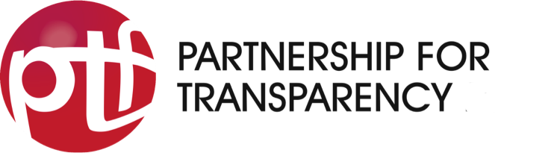 | 