50th ADB Annual Meeting
Civil Society Program

Panel for PTF and World Vision International sponsored event as part LwP.

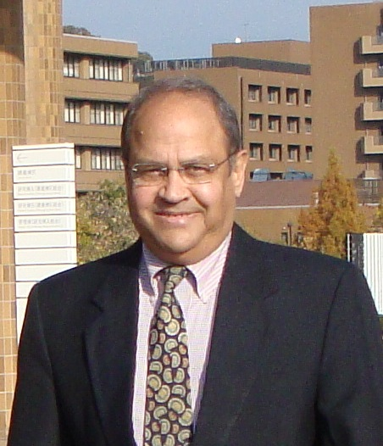 | Name of Speaker: Dr. Vinay Bhargava  Position: Chief Technical Adviser  Organization: Partnership for Transparency Fund (PTF, www.ptfund.org)  Email: vbhargava@ptfund.org
Dr. Vinay Bhargava is Chief Technical Adviser and Board member at an international NGO - the Partnership for Transparency Fund (www.PTFUnd.org). PTF is a volunteer’s organization and supports citizen engagement with governments to improve development effectiveness through transparency, accountability and reduced corruption. He teaches at George Washington University, USA and at Kobe University, Japan. He has worked as a development specialist in South Asia, East Asia, Western Africa, Eastern Europe and Middle East. He is a former Country Director and former Director, International Affairs at the World Bank. He has written and spoken extensively on the subject of fighting corruption particularly through citizen and civil society led programs. He has authored several books and contributed chapters in many others such as: Global Issues for Global Citizens; Challenging Corruption in Asia; Many Faces of Corruption; Citizens Against Corruption; and Ending Asian Deprivations.

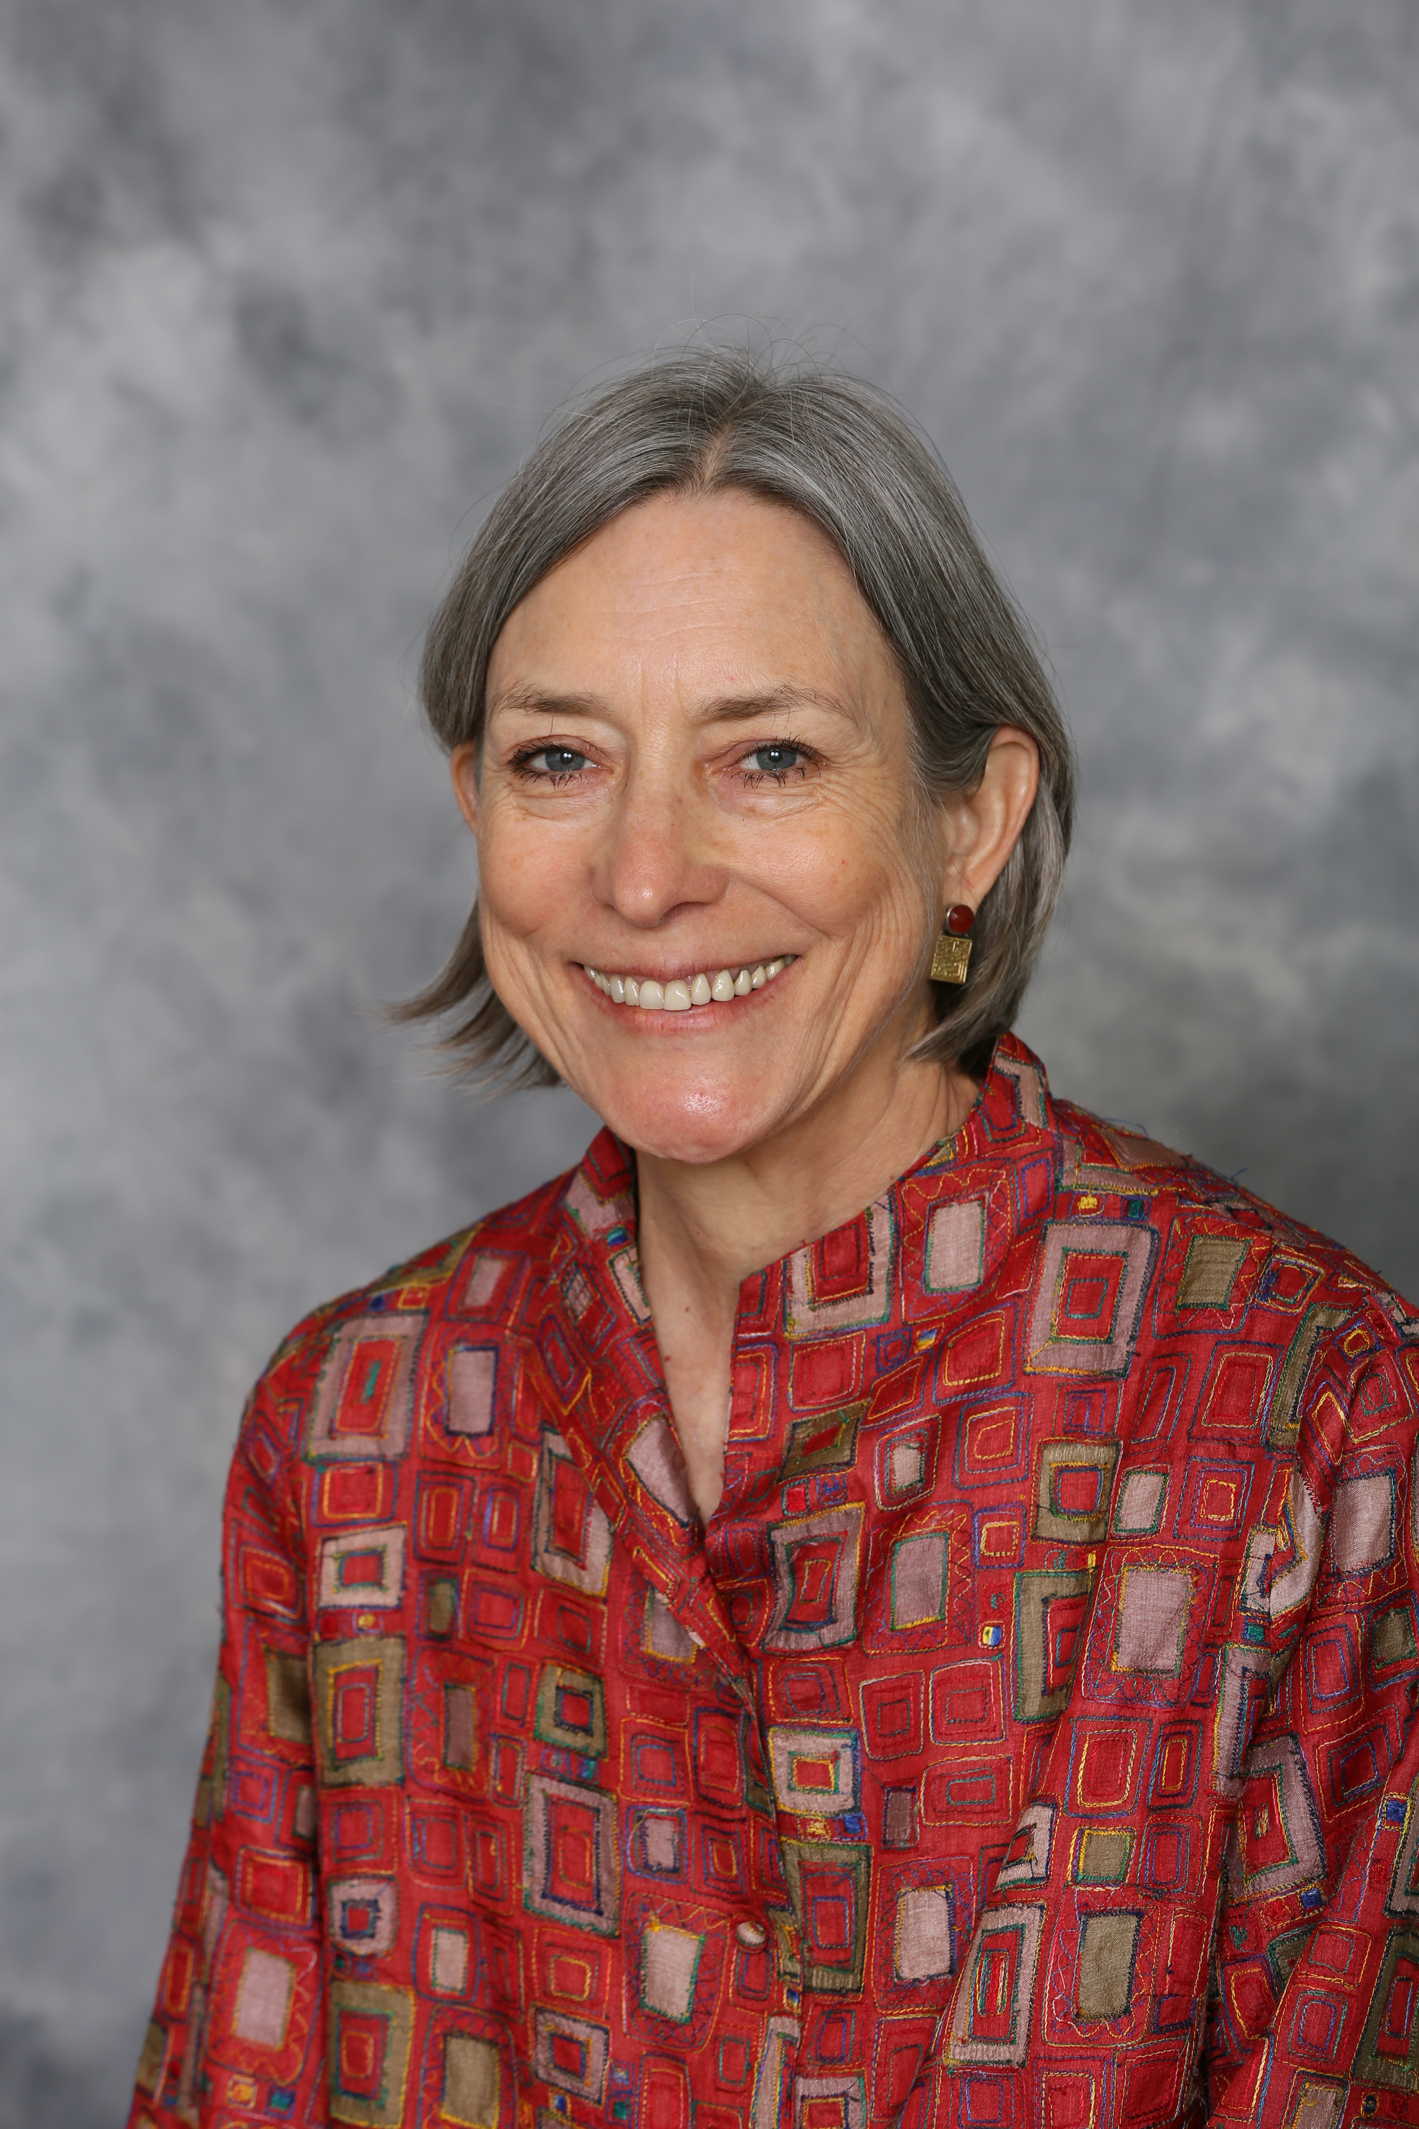 | Name of Speaker: Ms. Suzanne E. Siskel  Position: Executive Vice President & Chief Operating Officer  Organization: The Asia Foundation, http://asiafoundation.org  Email: suzanne.siskel@asiafoundation.org
Suzanne E. Siskel is Executive Vice President and Chief Operating Officer of The Asia Foundation. She oversees the organization’s 18 country offices throughout Asia as well as its San Francisco headquarters and office in Washington D.C. Suzanne worked at the Ford Foundation from 1990 to 2011, serving in various leadership positions in field offices in Southeast Asia and in its New York headquarters. Just prior to joining The Asia Foundation, Suzanne served as Ford’s director of Social Justice Philanthropy, overseeing efforts to mobilize philanthropic resources and to build strong local and regional foundations engaged in social development in the United States and throughout the world. Ms. Siskel joined the Ford Foundation in 1990 as program officer for Rural Poverty and Resources in Jakarta and later headed its offices in Indonesia and the Philippines. In these roles she was engaged in strengthening civil society; promoting economic development and community-based natural resources policy; and enhancing local capacity for socioeconomic research and analysis. Moving to New York in 2005, she directed Ford Foundation’s Community and Resource Development unit, providing support to organizations working in community development, local philanthropy, sexuality and reproductive health, and environment and development in Africa, Asia, Latin America, Russia, and the United States. Trained as a social anthropologist, Ms. Siskel has served variously as a consultant, university teacher and researcher throughout Indonesia, in rural northeast Brazil, and highland Chiapas, Mexico. She first lived and worked in Indonesia as a member of the first cohort of Luce Scholars in 1974 and later returned there as a Fulbright scholar and development advisor. She has served as president of the Fulbright Association; represented the Ford Foundation on the Governing Council of the European Foundation Centre and was a distinguished visiting scholar at the Center on Community Philanthropy, Clinton School of Public Service at the University of Arkansas. Currently she serves on the boards of Winrock International, China Medical Board, and the Youth Orchestra of the Americas, and is a member of the Global Philanthropy Committee of the Council on Foundations. Ms. Siskel studied anthropology at Harvard University and The John Hopkins University.
Name of Speaker: Ms. Pia S. Cayetano
Position: Deputy Speaker
Organization: House of Representatives, the Philippines

Email:

Deputy Speaker Pia S. Cayetano stands tall as a champion of women, children, health and education. She is a mother, lawyer, triathlete and entrepreneur. Cayetano represents the second district of Taguig, one of the most progressive and highly urbanized cities in the Philippines. She previously served in the Senate for two terms (2004-2016), where she led the passage of several landmark measures advancing the interest of women, children and the elderly, public health services and making quality education accessible to all.
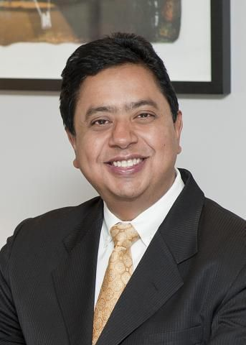 | Name of Speaker: Mr. Sanjay Pradhan  Position: Chief Executive Officer  Organization: Open Government Partnership  Email:
Sanjay Pradhan joined OGP in May 2016 as Chief Executive Officer. He previously served in three senior positions at the World Bank: as the Vice President for Leadership, Learning, and Innovation, the Vice President of the World Bank Institute, and the Director for Governance. Sanjay is a global spokesperson on open governance, appearing in major world forums including the European Parliament and the TED Global Conference . He has published widely, and was a principal author of the 1997 World Development Report . He holds a PhD from Harvard University.

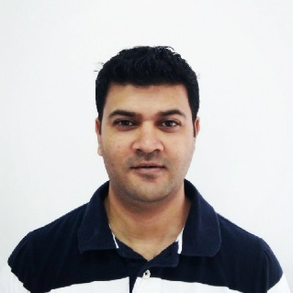 | Name of Speaker: Mr. Deepesh Paul Thakur  Position: Director of Advocacy and Justice for Children, South Asia and Pacific Regional Office  Organization: World Vision International  Email: deepesh_paul_thakur@wvi.org
Deepesh Thakur is World Vision International’s Director for Advocacy and Justice for Children for the South Asia and Pacific Regional Office. Holding this role since 2014, he provides strategic leadership to World Vision’s advocacy and social accountability programming in the Region, including technical support to 7 National Offices’ child centered advocacy and social accountability strategies and plans. As Regional Advocacy lead, Deepesh collaborates with broader regional mechanisms aimed at improving government structures and systems in South Asia and Pacific.
Prior to this, Deepesh worked in Mongolia as World Vision Mongolia’s Director for Public Engagement and through this led World Vision Mongolia’s engagement with and influence on government policy to promote child protection and rights. Deepesh has also worked in Nepal in various capacities, including led World Vision Nepal’s’ efforts to influence government policy and practise to provide greater benefit and services to vulnerable children and their families. Deepesh has also worked in local communities, directly implementing local development projects (with local NGOs). Deepesh holds a Master’s degree in Human Right and Business Studies.

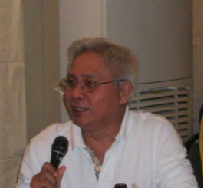 | Name of Speaker: Mr. Dante de los Angeles  Position: PTF Adviser and Secretary and Treasurer  Organization: PTF Asia Foundation (www.ptfund.org)  Email: ddelosangeles@ptfund.org
Dante de los Angeles is PTF Director and Secretary/Treasurer of PTF Foundation Asia, Manila, the Philippines. Dante serves as PTF Adviser since 2010. He was PTF Board Member from 2011 to 2015 and Regional Coordinator for Africa (2011 to 2012) and Regional Coordinator for East Asia (2012 to present).He is a member of the Board of Directors of Resources, Environment and Economics Center for Studies, Inc., a Philippine based action-research private organization that specializes in the economics of natural resource and environmental management including accounting for natural capital and ecosystem services. He was also former CEO of the Orient Integrated Development Consultants, Inc., a leading Filipino consulting firm, where he championed the use of holistic project approach that weaves into the core element of projects the concerns of economic/social development, governance, and environment security (or EDGE Approach) to create impacts that maximize the long-term sustainability of projects.

Dante has more than 30 years of public and private sectors experience in rural and institutional development, particularly in planning, procurement and oversight for good governance of foreign-assisted projects on governance and decentralization, integrated area development, natural resources and environmental management, institution and capacity building, and the empowerment of communities for sustainable development. Implemented mostly in the complex conditions of underdevelopment and armed conflict, these initiatives received funding from USAID, AusAID, CIDA, JICA, WB, ADB, JBIC, and the EU.

He served in various government positions before joining the private sector in 1992. He assisted in the organization and leadership of the Department of Labor’s Bureau of Rural Workers, an agency dedicated to promoting the welfare of millions of Philippine landless rural workers. He subsequently joined the National Council for Integrated Area Development of the Office of the Prime Minister to help manage a 7-year integrated area development project funded by the Australian Government involving 19 national and provincial agencies that collaborated for the development of Zamboanga del Sur, one of the poorest Muslim provinces in Mindanao. In a concurrent capacity, he served as Deputy Staff Director of the Local Affairs Office in charge of reviewing, monitoring and evaluating government policies on decentralizing programs to the regions and local government units.

Dante has a Master of Management degree from the Asian Institute of Management, Philippines, and undertook post graduate courses at the School of Economics, University of the Philippines.

